Project Development Phase
Functional & Performance Testing
Date | November 2026
Student Name | Rachabathula Gnana Sruthi
Project Name | Automated Network Request Management
Maximum Marks

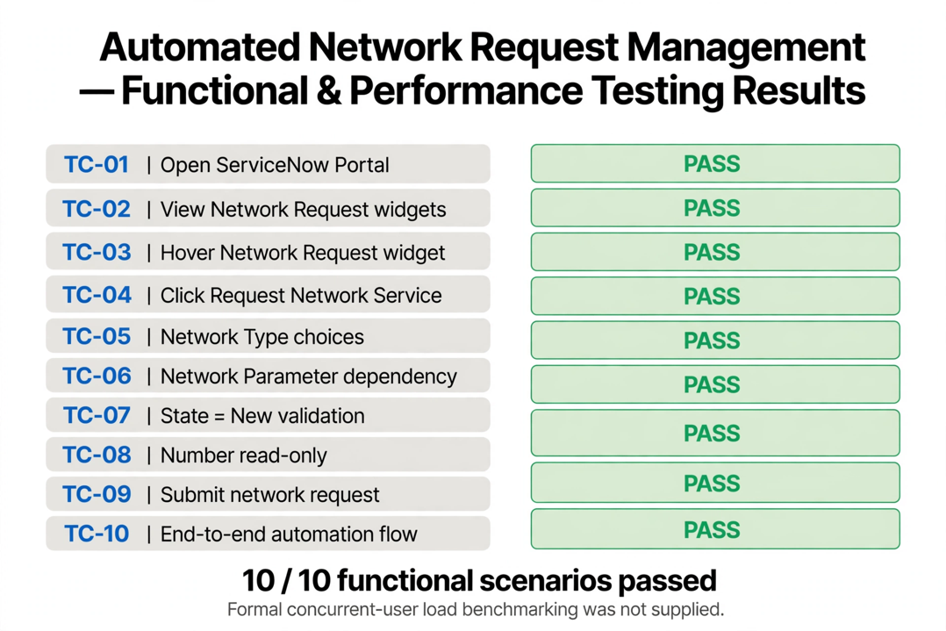
Test Scenarios & Results
Test ID | Scenario | Expected Result | Status
TC-01 | Open portal | Service Portal (/sp) loads. | Pass
TC-02 | View widgets | Network request widgets visible. | Pass
TC-03 | Hover widget | Floating effect visible. | Pass
TC-04 | Click Raise Ticket | Record Producer form opens. | Pass
TC-05 | Category | Choices available | Pass
TC-06 | Subcategory | Dependent choice works | Pass
TC-07 | State = New | Mandatory network parameters required. | Pass
TC-08 | Number | Request Number is read-only. | Pass
TC-09 | Submit | Backend record created in u_network_requests. | Pass
TC-10 | End-to-end | Complete flow works with approvals. | Pass

Figure 1: Functional test result representation for Automated Network Request Management.
Formal concurrent-user load benchmarking was not supplied.

